Advance POS System with Stock Manager -User Manual
Advance POS System with Stock Manager (APOS) is a multi-functional complete web application developed using ASP.NET Core and EF Core code first technology. This web application enables you to manage all kinds of retail shop and small business through proper monitoring and a dynamic reporting system.
APOS is a .NET Core/jQuery-based web application that allows you to manage your sales and inventory from anywhere. It has a built-in Invoice and Inventory System with taxes and discounts. These will be really helpful to apply taxes and discounts automatically and the ability to generate invoices.
Update your stock information, make purchases and view sales data from anywhere whether in the office, at home, in the warehouse, or on the go. All you need to access this a device with internet connection.

Core Feature
Dashboard
With Overview & Best Seller Pie Chart, Latest Eight (Invoice Today, Invoice Monthly, Sales Today, Sales Monthly, Customers & Suppliers) items summary.

Invoice Management
Easily track invoice that is in the register and manage additions and removals from the register. Reporting is also available for this to easily track shortages and overages.

Inventory Management
Do whole or partial inventory counts and stay up to date with history and proper reporting.

Item Variations
Create different sizes, categories, or any attributes you define for your items. You can track inventory down to the variation and even have different prices per variation.

Item modifiers
Modify inventory item, customer invoice easily. Choose add-ons to dishes or how they're prepared in one click.

Reports
Get comprehensive insights into your business with 10+ detailed reports designed for you. Overview & item stock, product quantity and damage item, general profit and/or loss report, sales, purchases, customer, suppliers and staff user reports.
Currency Exchange
Easily accept any Currency Denomination While making a Sale or Return.

Barcode Label Printing
Easily create barcode labels for your products when they arrive in your store or on-demand.

Payment Type
Credit Card, EBT/EBT Processing, Cash, Check, Gift cards you can define your own custom payment methods.

Serial Numbers
You can now manage items with serial numbers, relation with barcode and optionally you can also assign different prices depending on the serial number.

Custom Receipts
Easily customize your receipts to match what you need for your business. There are 5 different configuration options for making your receipts how you want them.

Inventory history
Gain insights into the flow of your inventory by viewing the adjustment log.

Admin LTE Theme:
Use the excellent and responsive theme in a low ambient light environment to reduce eyestrain. It provides a range of responsive, reusable, and commonly used components.

People
Manager, staff users, billers (selling companies), customers, and suppliers.

Settings
Easily manage the app with settings for logo, categories, variants, currencies, custom page access, and identity option.

Much more
User login history, user management, email configuration, nice UI.

Technical Features
- ASP.NET Core 6.0
- EF Core code first
- Identity Core
- MSSQL/MySQL
- Partial page update CRUD operation
- Razor and jQuery for FE
- jQuery DataTable for faster data load
- Sweet Alert2 and Toaster notification
- select2 dropdown
- ASP.NET Core MVC Architecture
- Swagger for API documentation
- Dependency Injection
- Standard Naming conventions
- JWT Token Based Authentication and Claim Based Authorization
- All Methods are Async/Await
- CORS Settings
- Docker Support
- Multi Language
- Audit Trail

Technologies:
Microsoft Visual Studio Community 2019 or later, ASP.NET Core 6.0, Identity Core, Entity Framework Code First, MSSQL SERVER 2017/MySQL, AdminLTE 3.0.5, JavaScript, jQuery data table, bootstrap 4, sweetalert, toastr, Fontawesome etc.

Prerequisite Application:
Microsoft Visual Studio Community 2019 or later, .Net Core 6.0, MS SQL SERVER 2017/MySQL, IIS, Chrome/Edge Browser.

How to run this Project:
Step 1:
Unzip the downloaded zip folder (AdvPOS.zip)
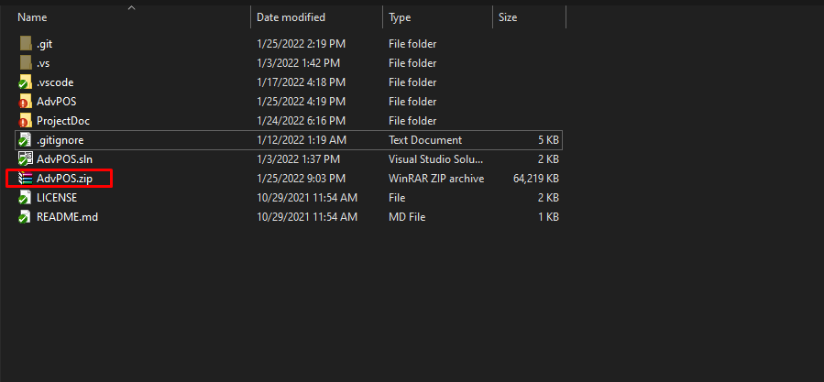
Step 2:
Open AdvPOS.sln file with Visual Studio 2019
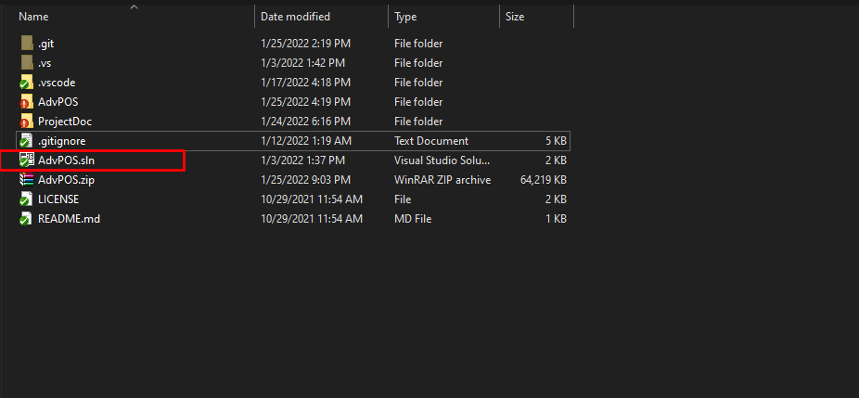
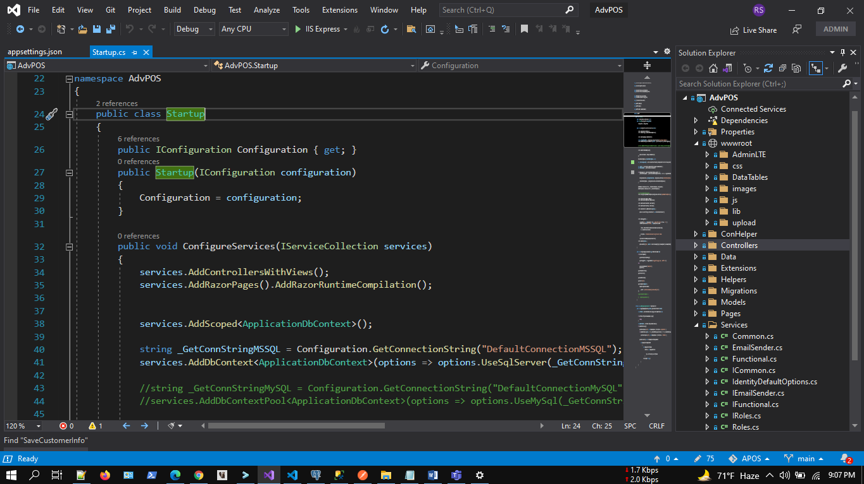

Step 3:
Update database connection: appsettings.json
“DefaultConnection”: “Server=DEVSTATION\\MSSQLSERVER2017; Database=AdvPOSDev;User ID=sa;Password=dev123456”
Server=Your MSSQL Server Name
User ID= Your MSSQL Server User Name
Password= Your MSSQL Server User Password

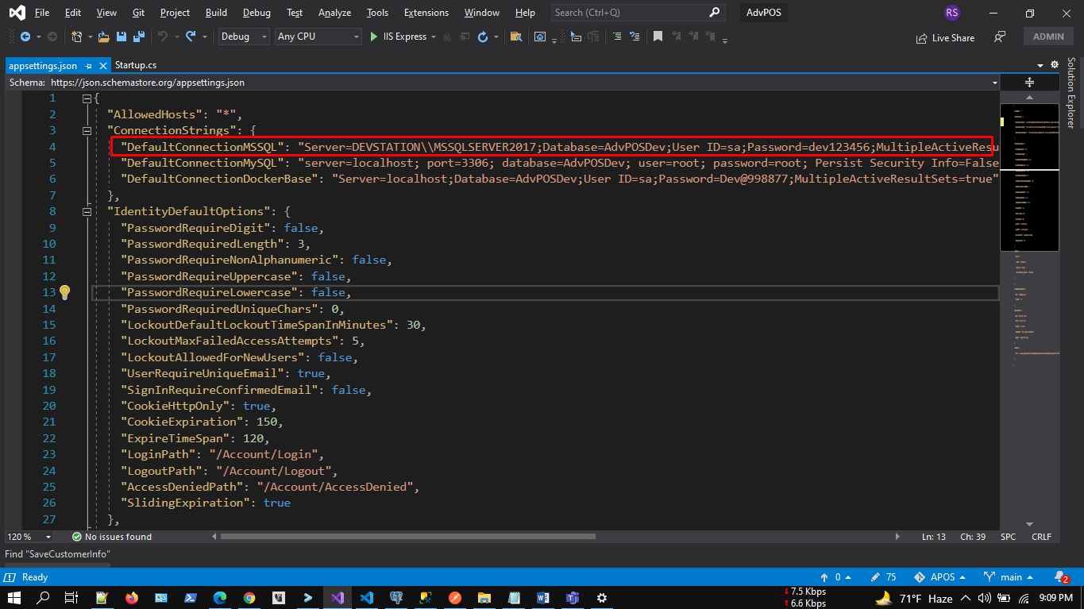

Step 4:
No need to create new migration rule and update database. You just need to build and run the application. Already initial migration rule included with project. Please make sure MS SQL server running properly.
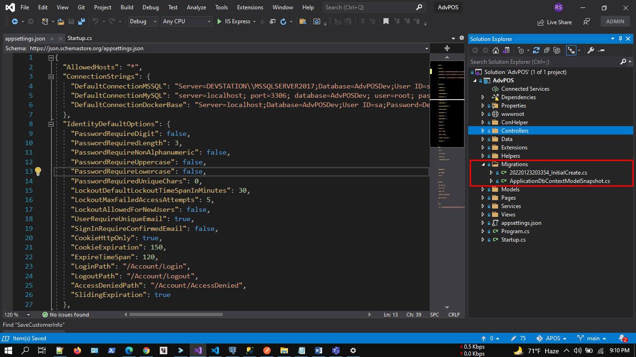

Step 5:
5.1: Build application by pressing f6
5.2: Run application by pressing f5
https://localhost:5001/
Swagger:
http://localhost:5000/swagger/index.html

Initially in the SQL server, relevant tables and data will be created in the database dynamically as code first approach.

Step 6:
Browse full application.
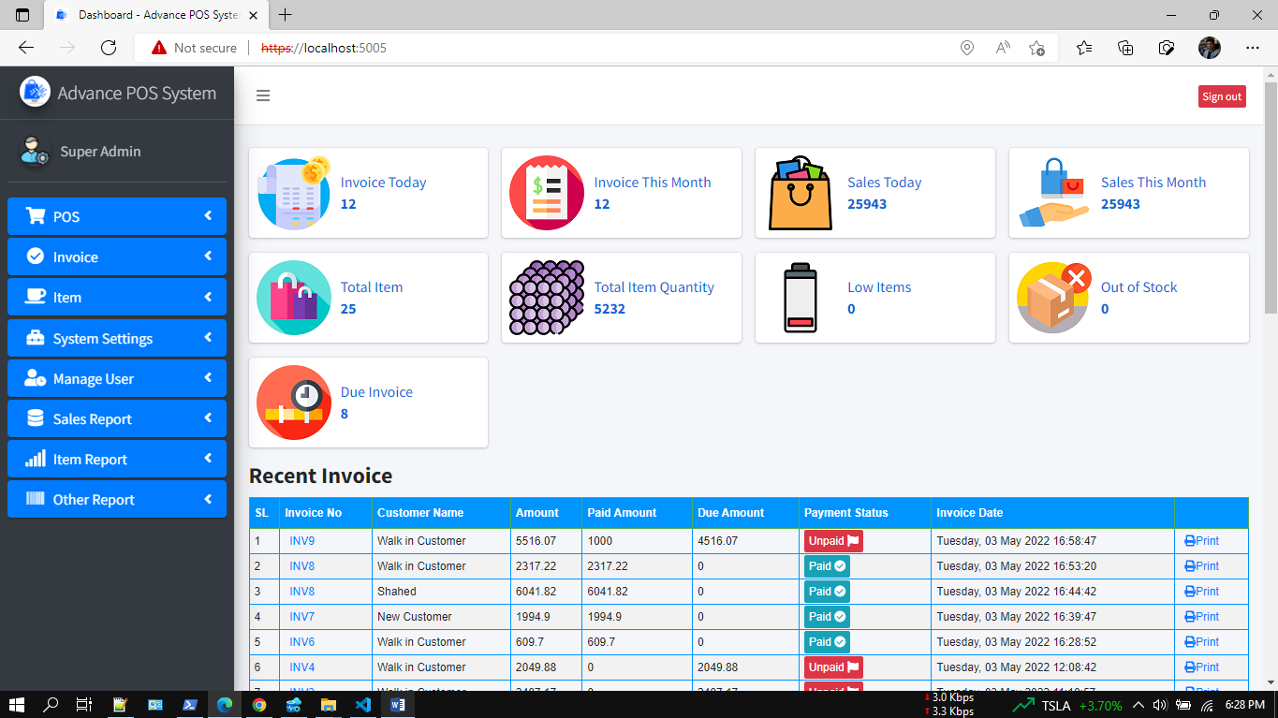

Payment Summary Report:
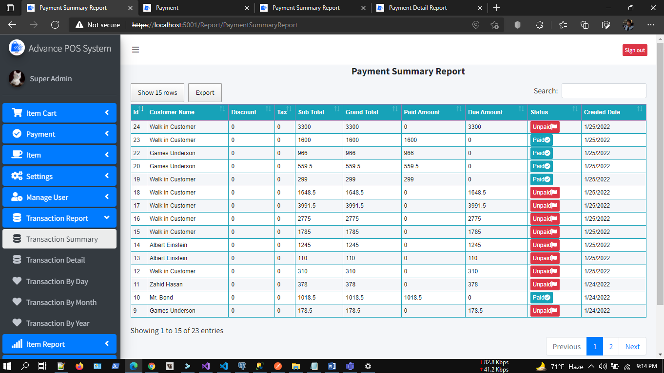
Product Wise Sale Report
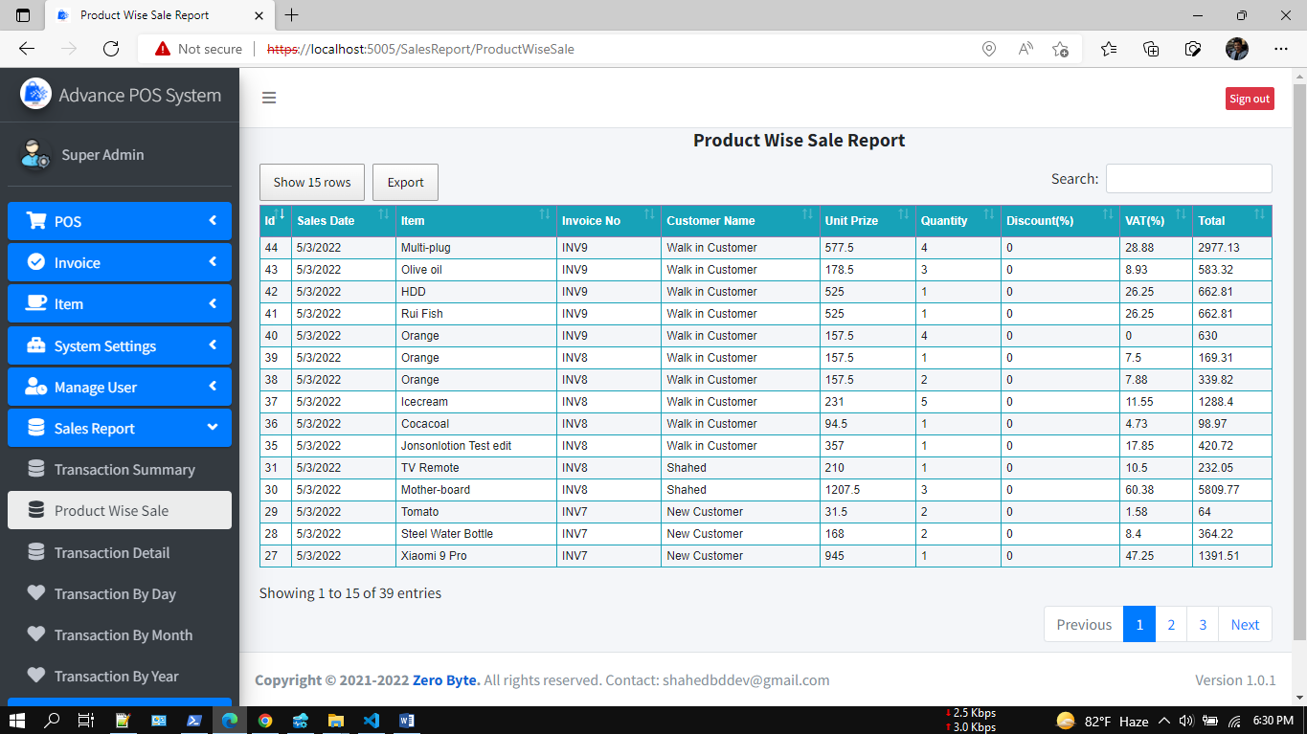

Payment Detail Report:
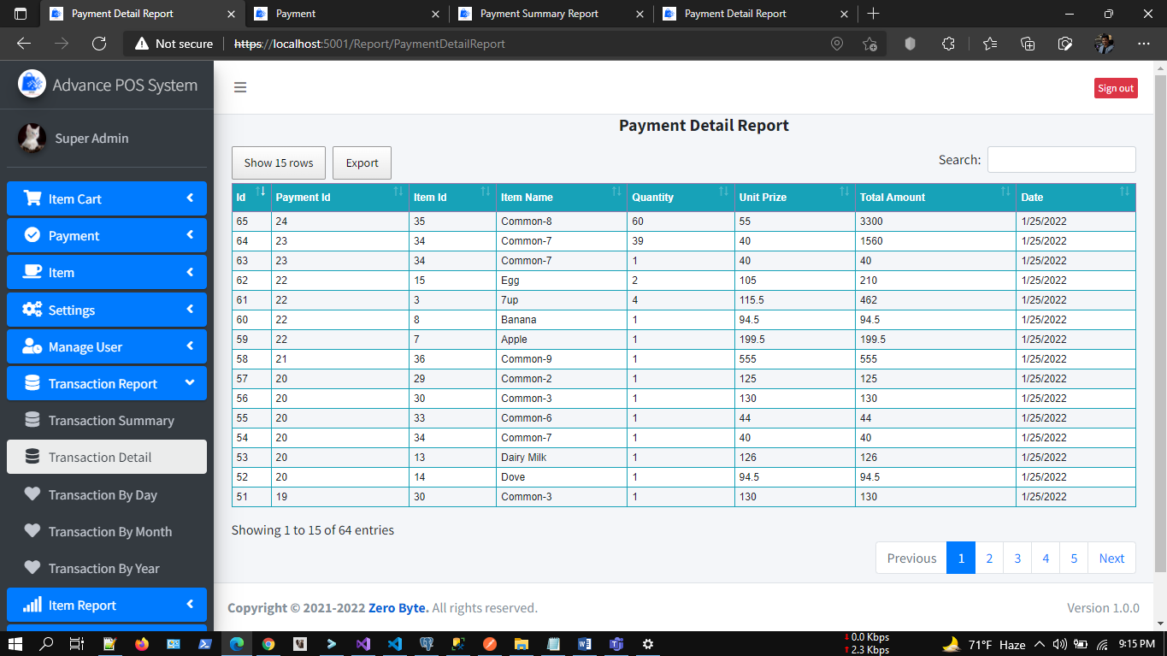

Transaction by Month Report:
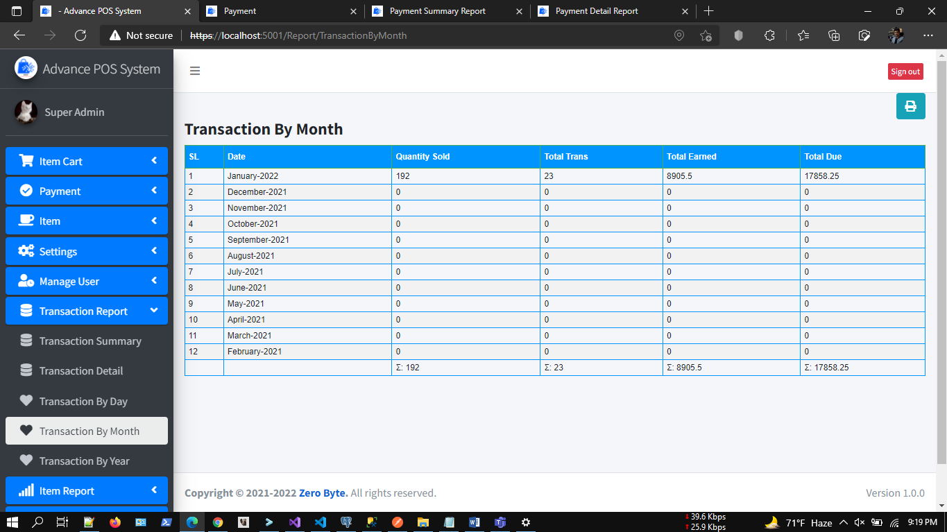

Item: Highest Earning Report:
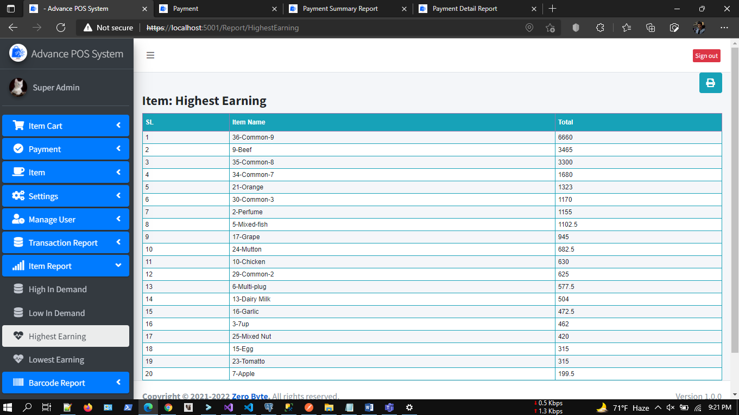
Print Barcode
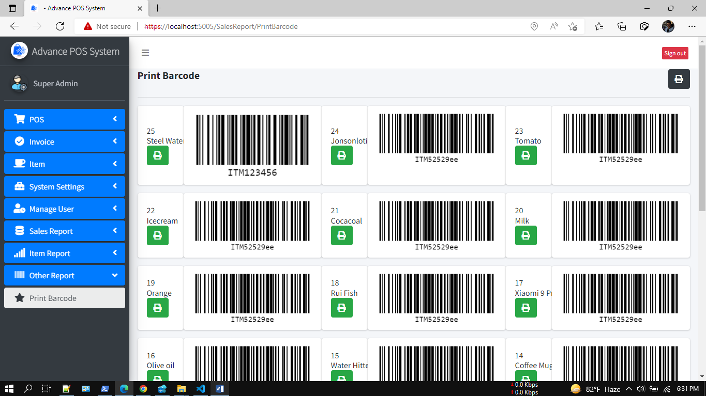

Demo Video Preview
https://youtu.be/8MscStpYxtE
App Screenshot:
https://photos.app.goo.gl/HPL8babMdwGBcpWSA

DB Migration:
Tools--> Nuget Package Manager--> Package Manager Console

PM> add-migration initcreate
PM> update-database

Check .Net Version:
Press Windows + R.
Type cmd.
On the command prompt, type dotnet --version

Tutorials:
IIS Deployment: https://www.youtube.com/watch?v=2el2EaII3PY&
DB Connection: https://www.youtube.com/watch?v=2Mv4-S-Cdw0&
MySQL DB Connection: https://www.youtube.com/watch?v=dt4M4SpgR5o

Supports:
If you want to modify or add new features, or any technical issues you have faced during installation you can always contact us at,
WhatsApp: 8801674411603
Telegram: shahed71bd
Skype: shahedatomap
Email: shahedbddev@gmail.com
Youtube: https://www.youtube.com/channel/UCdHAVwuNUtfqZRFVI6qf7mg

